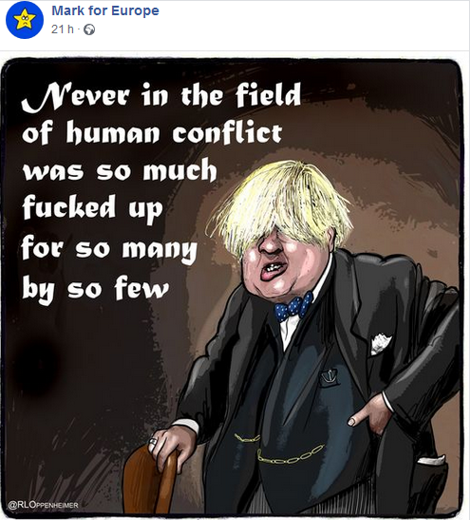

==================================================================================

Never in the field of human conflict was so much owed by so many to so few (Winston Churchill)
Premier's review of the War
Wednesday 21 August 1940

