TEST DE NIVEAU 2 - VOCABULAIRE

The body
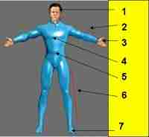
Chest Head Foot Belly Leg Hand Knee Arm

The face
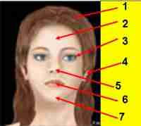
Nose Mouth Forehead Eye Ear Chin Hair

The family
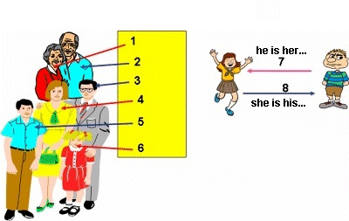
Mother Daughter Father Sister Grandfather Son Brother Grandmother

The House
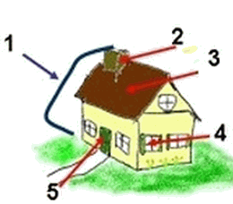
Roof Window Door Chimney House

The bedroom
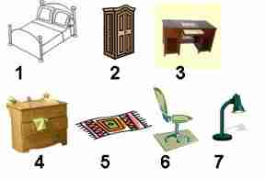
Chair Lamp Desk Wardrobe Chest Bed Rug

In the kitchen
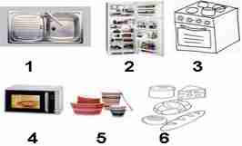
Refrigerator Stove Sink Microwave Food Crockery

On the table
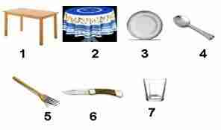
Table Spoon Glass Knife Fork Tablecloth Plate

In the living room
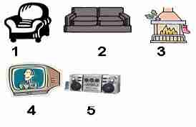
Fire place Television HiFi system Armchair Sofa

Some clothes
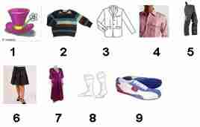
Shirt Jacket Pair of trousers Dress Socks Hat Pullover Pair of shoes Skirt

In the street
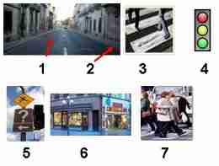
Traffic lights Pavement Signboards Street Pedestrians Zebra crossing Shops

Means of transportation

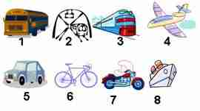
Boat Bus Bicycle Car Plane Train Tube Motorcycle

Your day
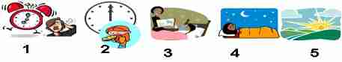
At night At noon In the day time In the evening In the morning

The seasons
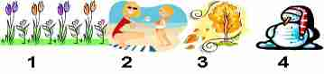
Spring Summer Winter Autumn

The weather
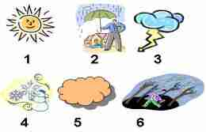
Wind Cloud Snow Sun Rain Cloud

The environment
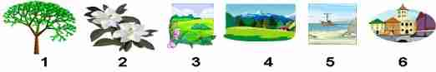
Flowers Tree Mountain Countryside City Sea

Some animals
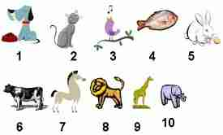
Elephant Rabbit Horse Lion Fish Cow Bird Cat Dog Giraffe

